Real Time Path Tracing for Reconnaissance and
Rescue Operations

Akshat Verma ( B.Tech),
Srimathi R,
Shashwat Mishra ( B.Tech),
Electronics and Computer Engineering,
Assistant Professor, School of
Electrical and Electronics Engineering,
School of Electrical Engineering,
Electrical Engineering, Vellore
School of Electrical Engineering,
Vellore Institute of Technology,
Institute of Technology, Chennai,
Vellore Institute of Technology,
Chennai, Tamil Nadu, India
Chennai, Tamil Nadu, India
akshat.verma2022@vitstudent.ac.in
shashwat.mishra2022@vitstudent.ac.in.

The primary objectives of this research are to enhance
Abstract—
In recent years, the increasing occurrence of
rescue operations in hazardous environments, such as disaster-
situational awareness, reduce response time, and improve the
stricken areas and collapsed structures, has emphasized the
efficiency of rescue operations, particularly in environments
need
for
efficient,
real-time
mapping
and
path
tracing
where
traditional
navigation
methods
are
ineffective.
By
technologies.
This
paper
presents
the
design
and
enabling real-time mapping, visual feedback, this system
implementation
of
a
"Real-time
Path
Tracing
System
for
provides a robust foundation for future advancements in
Reconnaissance
and
Rescue
Operations,"
a
low-resource
robotic-assisted rescue missions..
solution
aimed
at
enhancing
situational
awareness
and
operational
efficiency
in
such
environments.
The
system

I.
L
R

ITERATURE
EVIEW
integrates
an
ESP32-CAM
module
for
real-time
video
acquisition, paired with VL53L0X TOF sensors to provide
Recent
advancements
in
real-time
path
tracing
and
accurate
distance
measurements.
By
combining
visual
reconnaissance operations have increasingly relied on the
odometry
with
TOF
data,
the
system
creates
dynamic
integration of lightweight Time-of-Flight (TOF) sensors and
occupancy
grids
and
reliable
maps
for
navigation
in
visual
cameras
for
accurate
mapping and localization
in
constrained environments. The real-time trajectory tracking is
hazardous
environments.
In
particular,
ESP32-CAM
powered by OpenCV for feature detection and pose estimation,
modules have gained attention for their ability to provide
ensuring high positional accuracy with minimal error. This
real-time video
streaming
and
visual odometry,
enabling
approach
significantly
advances
the
capabilities
of
robotic
enhanced
situational
awareness
during
reconnaissance
systems in search and rescue missions, offering improvements
missions. Previous works, such as those by Liu et al. (2024) ,
in
response
time,
accuracy,
and
operational
reliability,
introduced
novel
dense
SLAM
systems
that
leverage
particularly in environments where traditional methods are
monocular
cameras
and
lightweight
TOF
sensors,
less effective.
highlighting their potential for real-time camera tracking and
dense scene reconstruction. The integration of TOF sensors
Keywords—Real-time
Path
Tracing,
Reconnaissance
and
with RGB cameras has shown promising results in enhancing
Rescue
Operations,
ESP32-CAM,
Time-of-Flight
Sensors,
VL53L0X Sensors, Visual Odometry, Remote Control, Real-time
the
robustness
and
accuracy
of
dense
SLAM,
even
in
Video
Streaming,
Distance
Measurement,
Web
Interface,
environments
with
sparse
and
noisy
depth
data
.
OpenCV,
I2C
Communication,
DC
Motors,
Motor
Control,
Additionally, temporal filtering techniques, as discussed in
Obstacle Detection, Robot Localization, Situational Awareness,
recent studies, have been explored to mitigate the noise and
Search and Rescue Robotics, Low-cost Robotics Solution, SLAM.
missing data issues inherent in low-resolution TOF signals,
further improving depth prediction and map generation .
In recent years, the increasing frequency of hazardous
These
innovations
pave
the
way
for
more
efficient
and
events, such as natural disasters and structural collapses, has
scalable solutions for mapping and path tracing in critical
underscored the need for efficient and reliable technologies
rescue scenarios, where precise and real-time environmental
to support reconnaissance and rescue operations. Traditional
mapping is crucial for decision-making and navigation[1].
methods often rely on manual interventions, which can be
In the field of real-time path tracing for reconnaissance and
slow and risky in dangerous environments. This research
rescue
operations,
recent
advancements
in
multi-sensor
presents
a
Real-time
Path
Tracing
System
for
SLAM
systems
have
significantly
enhanced
robotic
Reconnaissance
and
Rescue
Operations,
a
low-cost
and
navigation in complex and hazardous environments. The use
efficient solution that combines real-time video streaming,
of LiDAR and visual sensors in tandem with Time-of-Flight
distance measurement, and mapping for remote-controlled
(TOF) sensors has proven effective in creating accurate,
robotic systems.
dynamic
3D
maps
necessary
for
navigating
hazardous
The system integrates an ESP32-CAM module, capable
environments. ESP32-CAM, a low-cost and compact camera
of providing real-time video feeds, and VL53L0X Time-of-
module, has been widely utilized in such systems for real-
Flight (ToF) sensors for precise distance measurements. By
time video streaming, significantly aiding in path tracing and
combining visual odometry with ToF sensor data, the system
environmental monitoring. Recent studies, such as those by
constructs dynamic, real-time maps and occupancy grids for
Vega-Torres et al. (2024), focused on LiDAR-based SLAM
navigation
in
challenging
environments.
This
approach
combined with Inertial Measurement Units (IMUs) for long-
leverages OpenCV for real-time trajectory tracking and pose
term mapping in dynamic environments . These approaches
estimation, ensuring high positional accuracy for the robot
laid the foundation for multi-sensor fusion techniques that
even in constrained, GPS-denied areas. The low-cost nature
leverage visual cameras and TOF sensors to improve map
of the system, utilizing readily available components like the
accuracy
and
robustness.
Additionally,
SLAM2REF,
a
ESP32 and Arduino UNO, offers a cost-effective solution
framework integrating LiDAR, IMU, and reference map-
suitable for rapid deployment in disaster-stricken areas.
XXX-X-XXXX-XXXX-X/XX/$XX.00 ©20XX IEEE
based localization, demonstrated superior performance in 3D
complex environments. The integration of TOF sensors with
indoor
localization
for
robotics
in
environments
such
as
visual cameras such as the ESP32-CAM has been found to
disaster
zones,
where
GPS
and
traditional
navigation
improve the robustness and precision of mapping in both
methods fail . Combining these technologies with ESP32-
indoor and outdoor environments. For instance, SLAM2REF
CAM for real-time video streaming, as seen in works by Liu
has been implemented using LiDAR for highly accurate
et
al.
(2023),
enables
more
accurate
path
tracking
and
localization and real-time mapping . The fusion of visual
mapping in real-time, offering significant improvements in
odometry
and
TOF
sensors
with
ESP32-CAM
has
been
reconnaissance operations, especially in complex, cluttered,
explored to further enhance real-time mapping and obstacle
or dynamically changing environments[2].
detection, making it a powerful solution for disaster response
and search and rescue missions. Studies have also shown that
Recent
research
has
explored
various
strategies
for
neural implicit SLAM systems based on point-based implicit
enhancing
real-time
path
tracing
and
reconnaissance
neural maps achieve globally consistent mapping, even in
operations, focusing on autonomous mobile robots and real-
large-scale and dynamic environments, by employing neural
time
mapping
in
hazardous,
GPS-denied
environments.
network models for localization and loop closure correction .
Technologies
such
as
Simultaneous
Localization
and
These
studies
align
with
your
research
goals,
as
the
Mapping (SLAM), visual odometry, and depth sensors play
integration
of
ESP32-CAM
with
TOF
sensors
offers
critical roles in ensuring accurate localization and efficient
significant improvements in autonomous mapping, enabling
navigation.
ESP32-CAM modules, widely
recognized
for
real-time, efficient, and cost-effective reconnaissance and
their ability to provide live video feeds, have been integrated
rescue operations [5].
into
various
robotic
systems
to
aid
in
path
tracing
and
environmental mapping during rescue missions. For instance,

II.
O

VERALL SYSTEM AND ITS COMPONENTS
the integration of ESP32-CAM for real-time video streaming
was demonstrated in a robotic system designed for search

A.
Abbreviations and
and
rescue
operations,
enabling
remote
operation
and
Acronyms
enhanced situational awareness . The integration of TOF
sensors with visual data has also been explored in depth,

WiFi: Wireless Fidelity
•
showing its potential for creating dynamic and accurate maps

ToF: Time-of-Flight
•
in environments where traditional sensors fail. Studies such

ESP32: Espressif Systems 32-bit microcontroller
•
as those by Cao et al. (2023) discussed the use of LiDAR and

ESP32-CAM: ESP32 with a Camera module
•
monocular visual SLAM for robust localization in complex

I2C: Inter-Integrated Circuit (communication
•
environments . Furthermore, PIN-SLAM, a neural implicit
protocol)
mapping system, achieves high consistency in large-scale

VL53L0X: A Time-of-Flight (ToF) distance sensor
•
mapping by using a point-based neural map that enhances
model
both flexibility and compactness, making it well-suited for

operations in unpredictable and dynamic environments like
DC: Direct Current
•
collapsed structures or natural disaster zones [3].

PWM: Pulse Width Modulation
•

Wi-Fi: Wireless Fidelity
•
In the realm of real-time path tracing for reconnaissance and

HTTP: Hypertext Transfer Protocol
•
rescue operations, recent advances in SLAM systems and

WebSocket: A protocol providing full-duplex
sensor fusion have dramatically enhanced robotic navigation
•
communication channels over a single TCP
in complex, GPS-denied environments. The use of LiDAR
and visual sensors in tandem with Time-of-Flight (TOF)
connection
sensors has proven effective in creating accurate, dynamic

API: Application Programming Interface
•
3D maps necessary for navigating hazardous environments.

GPIO: General Purpose Input/Output
•
ESP32-CAM, a low-cost and compact camera module, has

SDA: Serial Data (I2C protocol)
•
been widely utilized in such systems for real-time video

SCL: Serial Clock (I2C protocol)
•
streaming,
significantly
aiding
in
path
tracing
and

RX: Receive (serial communication)
•
environmental monitoring. Recent studies, such as those by

TX: Transmit (serial communication)
•
Pan
et
al.
(2024),
have
demonstrated
the
potential
of

PWM: Pulse Width Modulation
•
combining LiDAR with implicit neural networks for global

LED: Light Emitting Diode
map
consistency
in
SLAM,
where
neural
point
clouds
•
support robust loop closure detection and pose estimation .

H-Bridge: A type of electronic circuit used for
•
These advancements are highly relevant to your research, as
controlling the direction of motors
integrating ESP32-CAM and TOF sensors offers a cost-

OpenCV: Open Source Computer Vision Library
•
effective yet precise alternative for real-time mapping in

FRAMESIZE_QVGA: Quarter Video Graphics
•
disaster response scenarios. Further, PIN-SLAM, a neural
Array (frame size)
implicit mapping system, achieves high consistency in large-

JPEG: Joint Photographic Experts Group (image
•
scale
mapping
by
using
a
point-based
neural
map
that
format)
enhances both flexibility and compactness, making it well-

Wi-Fi AP: Wi-Fi Access Point
•
suited
for
operations
in
unpredictable
and
dynamic

PSRAM: Pseudo-Static Random Access Memory
•
environments like collapsed structures or natural disaster

SHT: Shutdown (pin used to control the operation
zones [4].
•
of ToF sensors)
Recent research in real-time path tracing and reconnaissance

XSHUT: Shutdown pin (used to stop
•
for
rescue
operations
has
demonstrated
the
efficacy
of
communication with ToF sensors)
SLAM-based systems in creating real-time, accurate maps of
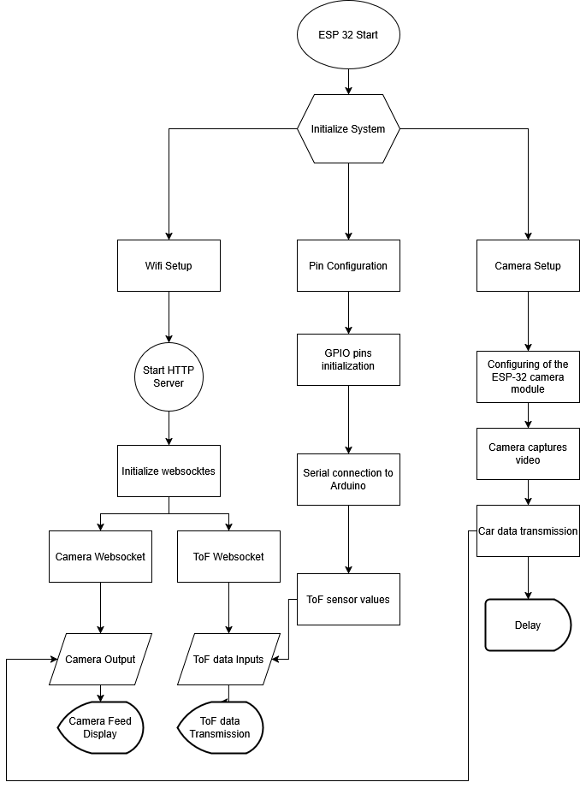

B.
Overview of the System
d)
Data Collection and Processing:

Camera Captures Video: The ESP32-CAM
o
The
Real-time
Path
Tracing
for
Reconnaissance
and
continuously
captures
video,
providing
Rescue Operations system leverages multiple components
real-time
visual
feedback
from
the
for seamless data collection, processing, and visualization.
environment.
The
system
is primarily controlled by
the ESP32-CAM,

TOF
Sensor
Data:
The
TOF
sensors
which handles the video streaming and motor control. The
o
Wi-Fi setup allows the ESP32 to connect to the network in
(VL53L0X)
measure
distances
to
access point mode, enabling remote communication via a
obstacles and transmit this data over the
web interface. The ESP32 communicates with VL53L0X
WebSocket
to
the
user
interface
for
Time-of-Flight (ToF) sensors, which measure distances to
navigation.
obstacles and send the data to the web interface for real-time

e)
Delay:
navigation.

Delay Handling: The system includes a
o
delay function to control the update rate
The
HTTP
server
initialized
on
the
ESP32
handles
for
video
streaming
and
sensor
data,
incoming requests from the web interface and establishes
preventing excessive data flow that could
two WebSocket handlers: one for camera data and another
overwhelm the network and slow down
for ToF sensor data. The camera continuously captures real-
time video, while the ToF sensors measure distances, which
system performance.
are
transmitted
to
the
user
interface.
This
enables
the

f)
Visualisation Interface:
operator to monitor both visual and distance data from the

The visualisation window consists of the
o
robot. The system processes and displays the information
localised position of the robotic
vehicle
using the matplotlib library for visualization, showing the
which is being mapped using matplot lib
vehicle’s position and surrounding obstacles. Additionally,
library of python and simultaneously ToF
Arduino UNO facilitates communication between the sensors
data is used to visualise the distance of
and the ESP32, ensuring smooth data transfer for real-time
various obstacles surrounding the robotic
processing
and
visualization.
The
integration
of
these
vehicle.
systems allows for efficient remote control, monitoring, and

g)
Repeat:
navigation in reconnaissance and rescue operations.

The loop continues, handling new requests
o
as they come in, and adjusting the servos

C.
System One: ESP-32
based on the web interface inputs.
Data Collection and

Transmission

a)
Initialize System:

WiFi Setup: The system starts by setting
o
up the WiFi in access point mode (Soft
AP).

Pin
Configuration:
The
GPIO
pins
for
o
motor
control,
servos,
and
lighting
are
initialized.

Camera Setup: The camera is initialized,
o
ensuring the proper configuration of the
ESP32 camera module.

b)
Connect to WiFi:

WiFi Connection: The ESP8266 connects
o
to the WiFi network using the credentials
defined in the code (ssid and password).

Check
Connection:
The
program
waits
o
until the device is connected to WiFi.

Display IP Address: Once connected, the
o
ESP8266 prints its IP address to the serial
monitor.

c)
Start HTTP Server:

The HTTP server is initialized to handle
o
requests from a web interface.

Two WebSocket handlers are added:
o
▪

Camera
WebSocket:
Handles
camera data and sends frames to
connected clients.

▪

ToF
data
WebSocket:
Handles

ToF
distance measurement data

transmission.
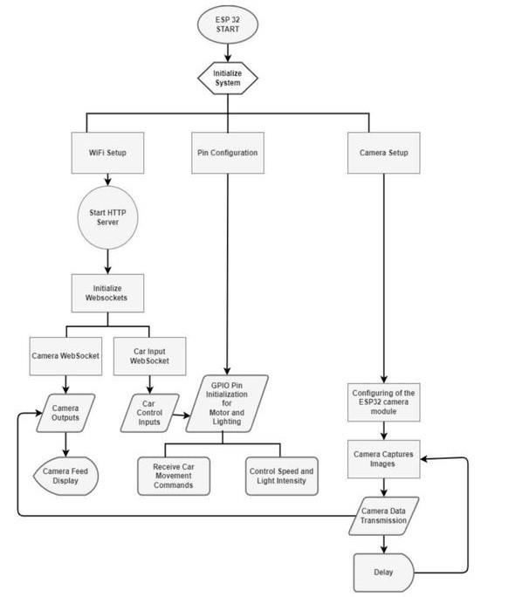

Controlling multiple sensors is achieved

D.
System Two: ESP-32
o
by using XSHUT pin of the sensor which
cam controlled
stops communication between the sensor

a)
Initialize System:
and microcontroller when cleared or set to

WiFi Setup: The system starts by setting
o
low.
up the WiFi in access point mode (Soft

b)
Serial Interface with ESP-32:
AP).

In order to transfer the measurements and
o

Pin
Configuration:
The
GPIO
pins
for
o
distance data aquired by the ToF sensors
motor
control,
servos,
and
lighting
are
we serially communicate between Arduino
initialized.
and ESP-32 microcontroller to ensure the
data
is
transmitted,
processed
and

Camera Setup: The camera is initialized,
o
visualised.
ensuring the proper configuration of the
ESP32 camera module.

b)
Start HTTP Server:

The HTTP server is initialized to handle
o
requests from a web interface.

Two WebSocket handlers are added:
o
▪

Camera
WebSocket:
Handles
camera data and sends frames to
connected clients.
▪

Car
Input
WebSocket:
Handles
car control commands, including
movement, speed, light intensity.

c)
Receive and Process Camera Data:

The camera captures images in a loop and
o
sends the image data to connected clients
via the Camera WebSocket.

d)
Receive Car Movement Commands:

The
system
listens
for
movement
o
commands sent from the web interface.

Based
on
the
received
command,
the
o
motors
are
rotated
in
the
appropriate
direction using rotateMotor().

e)
Control Speed and Light Intensity:

The sliders for controlling speed and light
o
intensity on the web interface are used to

adjust the PWM values.

III.
H

The PWM signals control the speed of the
o
ARDWARE IMPLEMENTATION
motors and the intensity of the light.
This section outlines the key hardware components and
their
connections
for
the
Real-time
Path
Tracing
for

f)
System Cleanup and Monitoring:
Reconnaissance and Rescue Operations system. It details the

The system periodically checks and cleans
o
integration of the ESP32-CAM, Arduino UNO, VL53L0X
up
WebSocket
clients,
ensuring
proper
Time-of-Flight sensors, L298N motor driver, and DC motors
memory usage.
to enable real-time video streaming, movement control, and
precise distance measurements for effective navigation and

It
also
monitors
the
heap
memory,
o
mapping.
including
PSRAM
usage,
and
prints
system status messages.

A.
Key Hardware
Components

E.
System Two: Arduino
Uno communication

Arduino Uno R3: The Arduino acts as the interface
•
between multiple VL53L0X Time of Flight Sensors

a)
ToF connection:
which transmit the data serially to ESP32 Cam for

Multiple
ToF
sensors
are
connected
to
o
further processing and visualization of data.
arduino using SDA and SCL pins of the
sensor
to
A4
and
A5
pins
of
the

ESP-32 Cam: The ESP32-CAM is a compact
•
microcontroller.
development board that integrates the ESP32
microcontroller and a camera module. It captures
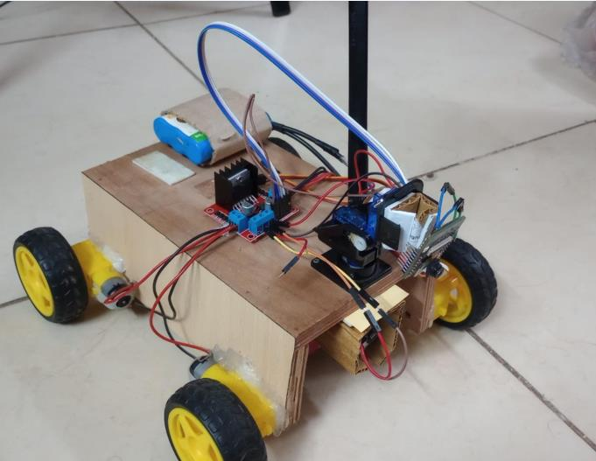
and transmits real-time video over Wi-Fi and
communication, enabling the user to control the
controls the DC motors and lighting. The ESP32-
robot remotely via a web interface.
CAM’s processing power and Wi-Fi connectivity

L298N Motor Driver (U5): The L298N is a dual H-
•
make it ideal for video streaming and motor control.
Bridge motor driver used to control the DC motors

VL53L0X Time-of-Flight Sensors: ToF sensors for
(M7 and M8) for the movement of the robot. The
•
measuring the distance around the robotic vehicle
motor driver receives control signals from the
the range we are using for this iteration is two
ESP32, such as direction and speed, and powers the
meters, the address of sensors are differed and xshut
DC motors accordingly. The L298N is connected to
pin is used to control the data flow from each sensor
the ESP32-CAM for controlling the motors' forward
to ensure precise and seamless communication of
and reverse motion and speed through PWM
necessary information .
signals.

L298N Motor Driver: The L298N is a dual H-
DC Motors (M7 and M8): The DC motors (M7 and
•
•
Bridge motor driver that controls the DC motors. It
M8) provide the motion for the robot. These motors
allows for the control of motor direction and speed
are controlled by the L298N motor driver based on
by adjusting the PWM signals sent from the ESP32,
the commands received from the ESP32. These
enabling the robot's movement.
motors control the movement of the robot, allowing
it to move forward, backward, and turn.

BO Motors: The BO motors are DC motors used
•

for the robot’s mobility. These motors are
VL53L0X Time-of-Flight Sensors(U6 and U7):
•
controlled via the L298N motor driver, allowing for
are used for real-time distance measurement by
movement in different directions and speed
emitting infrared light and calculating the time it
adjustments.
takes for the light to return. These sensors aid in
navigation and mapping in the system. They
communicate via I2C, with the SDA and SCL pins
connected to the ESP32 and Arduino for
transmitting sensor data. The XSHUT pin is used to
shut down the sensor when not in use, allowing the
microcontroller to control the sensor's power state
and save energy when necessary.

Arduino UNO (A1): handles low-level motor
•
control and sensor data processing in the system. It
connects to various peripherals through digital pins
D0-D13, which are used for controlling sensors and
facilitating communication. The analog pins A0-A5
are utilized for receiving analog inputs from sensors
or enabling communication with other components,
such as the TOF sensors. Additionally, the TX/RX
pins are used for serial communication with the

ESP32 and other modules, allowing for data

B.
Schematics and
exchange and coordination between the system
Connections
components.
The
schematic
provided
in
the
image
illustrates
the

Power Supply: The entire system is powered by an
•
hardware
setup
for
the
Real-time
Path
Tracing
for
appropriate DC power supply to ensure that both
Reconnaissance and Rescue Operations project, focusing on
the servos and motors receive adequate voltage and
the
integration
of
various
components
necessary
for
current. Each component is powered individually to
controlling
motors,
sensors,
and
communication
systems.
ensure stable operation, especially for the servos
This section explains the connections between components
and motors that require higher currents.
and
their
functionalities
to
support
the
overall
system

operation.
The
design
leverages
an
ESP32-WROOM-02

microcontroller, a L298HN motor driver, DC motors, and
VL53L0X TOF sensors for precise distance measurement.
The system is powered by two separate batteries (for the
ESP32
and
Arduino),
providing
the
required
power
for
different subsystems.

ESP32-Cam (U1 and U2): The ESP32-CAM
•
module is a combination of the ESP32
microcontroller and a camera module, and it is used
to transmit a live video feed from the robot. In this
schematic, it is connected to the L298N Motor
Driver to control the DC motors used for the robot's
movement. The ESP32 also handles Wi-Fi
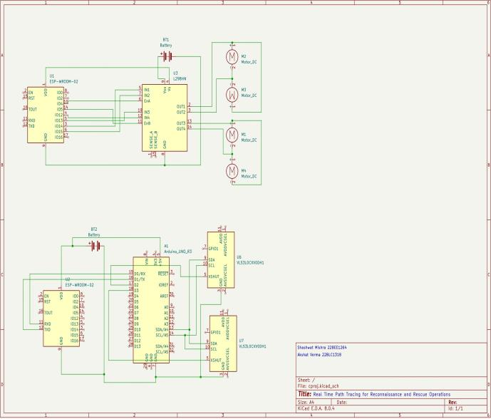

3.
Serial Data Route
(/serial): Sends the last
received serial data from
Arduino to the client.

d.
Arduino Communication: The ESP32
communicates with the Arduino over
serial using RX1 (pin 14) and TX1 (pin
12).

e.
Data Collection and Display:

i.
Camera Captures Video: The
camera captures real-time video
frames and continuously sends
them to the client via the web
interface.

ii.
ToF Sensor Data: Data from the
Arduino (e.g., distance
measurements from the ToF
sensors) is sent to the web

interface and updated every

second.

C.
Program Explaination

b)
ESP32-CAM Control (Movement and Camera
Feed):
The program used in this project is divided into three main

a.
Wi-Fi Setup: The ESP32-CAM connects
parts: one transmitting localised position and distance data
to the Wi-Fi network, allowing
(handled by the ESP32-CAM-2) , one for managing the
communication with the web interface.
robot's movement and camera feed (handled by the ESP32-

b.
Camera Stream: The ESP32-CAM
CAM-1) and an Arduino Uno R3 for facilitating the
captures video frames and streams them to
communication between sensors and the microcontrollers.
the web interface using WebSocket
Below is a breakdown of the code and its functionality:
communication. This allows users to view

a)
ESP-32-Cam-2 (Data Transmission):
live footage from the robot in real-time.

a.
Wi-Fi Setup and Access Point:

c.
DC Motor Control: The L298N motor

i.
The ESP32-CAM starts by
driver controls the DC motors based on
setting up a Wi-Fi access point
commands received via WebSocket. The
with the SSID "ESP32-CAM-
motor direction (forward, backward, left,
AP" and password "********".
right) and speed are controlled through

ii.
Once the Wi-Fi is set up, the
PWM signals from the ESP32.
ESP32-CAM’s IP address is

d.
WebSocket Communication: The ESP32-
printed to the serial monitor,
CAM communicates with the web
allowing remote access.
interface via WebSocket, handling the

b.
Camera Initialization:
input for movement, speed, and light

i.
The camera is initialized using
intensity adjustments. The real-time
the ESP32 camera configuration
control of the DC motors and the camera
(pins for data, XCLK, and
feed is made possible by the continuous
control signals are specified).
communication between the ESP32 and

ii.
The pixel format is set to JPEG,
the web interface.
and the frame size is set to

c)
Arduino Uno R3 (Serial Communication
QVGA. The camera is
Interface):
configured to stream JPEG

a.
Sensor Addresses and Shutdown Pins:
images in real-time.

i.
LOX1_ADDRESS and

c.
Web Server Setup:
LOX2_ADDRESS are defined as

i.
An HTTP server is started on
0x30 and 0x31, respectively, for
port 80 to handle requests from
the two VL53L0X sensors.
the web interface.

ii.
SHT_LOX1 and SHT_LOX2 are

ii.
Three main routes are defined:
defined as pin numbers 2 and 3,

1.
Root Route (/): Displays
respectively, to control the
the video stream and
shutdown of the sensors.
serial data from

b.
Sensor Initialization:
Arduino.

i.
VL53L0X sensor1 and sensor2

2.
Stream Route (/stream):
objects are created to represent
Streams live video feed
the two sensors.
from the ESP32 camera
to the client.

ii.
The setID() function initializes
fetch Time-of-Flight (ToF) distance
and sets the I2C addresses of the
measurements (front, left, and right),
sensors:
which are used for navigation and obstacle

1.
It starts by shutting
detection.

down all sensors by
e.
Bot Movement Logic: Using the front ToF
setting the shutdown
data, the bot decides whether to move
pins low.
forward or adjust direction to avoid

2.
It then boots and
obstacles. Orientation changes are made if
initializes sensor1 and
a nearby obstacle is detected.

sensor2 by setting the
f.
Path Tracking and Mapping: The bot's
shutdown pins high and
position is updated continuously on a 2D
verifying their
map. The path taken by the robot is drawn
initialization.
in green, and ToF sensor lines visualize

3.
The sensors are assigned
obstacle locations in real time.

their respective I2C
g.
Real-Time Visualization: The GUI shows
addresses: sensor1 gets
both the camera feed and 2D map
LOX1_ADDRESS, and
simultaneously, along with connection
sensor2 gets
status indicators to inform the user of
LOX2_ADDRESS.
communication health with the ESP32-

c.
Key Operations:
CAM.

i.
Distance Measurement: The
h.
Robust Connection Handling: The system
sensors continuously measure the
includes retry logic and error handling to
distance to objects in front of
recover from disconnections and maintain
them.
reliable communication during rescue

ii.
Error Handling: The code
operations.
includes error handling for sensor

IV.

RESULTS AND DISCUSSIONS
initialization and timeout events.

iii.
Output: The distance readings are

A.
Results
displayed in millimeters on the

serial monitor, along with a
message in case of timeouts.

Movement Control: The robot's movement is
•

d.
Basic Working: The system uses two
controlled via two DC motors (M7 and M8),
VL53L0X Time-of-Flight (ToF) sensors
which drive the robot forward, backward, or
to measure the distance to objects. Each
turn based on commands received through the
sensor is initialized and assigned a unique
web
interface.
The
L298N
motor
driver
I2C address for communication. The
effectively controls motor direction and speed,
ESP32/Arduino communicates with both
providing smooth movement of the robot. Users
can adjust the speed of the motors and change
sensors via the I2C protocol, retrieves the
their direction using the sliders in the interface.
distance values, and outputs them in real-
time. This setup is suitable for

Camera Feed: The ESP32-CAM module
•
applications requiring accurate,
successfully streams live video to the web
continuous distance measurement for
interface. This allows the user to see the robot’s
navigation or obstacle detection.
environment in real-time while controlling its

d)
Python Program(SLAM):
movements and actions. The camera feed was

a.
ESP32-CAM Integration: The system
stable, and the integration with the ESP32
connects to an ESP32-CAM in Access
allows for seamless control over both the robot's
Point mode to stream real-time video and
camera and movement simultaneously.
receive sensor data via HTTP and

WebSocket protocols.

System Integration and Functionality:
•

b.
Wi-Fi and Web Interface: Users are

The ESP32-CAM, VL53L0X Time-of-
o
prompted to connect their system to the
Flight sensors, and Arduino UNO were
ESP32-CAM's dedicated Wi-Fi network,
successfully integrated to form a
after which the program attempts to
cohesive system for reconnaissance
establish a connection and begin data
and rescue operations. This setup
collection.
enabled real-time video streaming,

c.
Camera Streaming: A video stream is
distance measurement, and
continuously fetched from the ESP32-
autonomous mapping.
CAM’s /stream endpoint and displayed

The ESP32-CAM served as the central
o
live in one half of the Python GUI using
unit, handling both video streaming
OpenCV and Matplotlib.
and motor control via the L298N motor

d.
ToF Sensor Data Retrieval: The system
driver. It also facilitated
regularly queries the /serial endpoint to
communication with the sensors to
potential for real-world applications,
continuously gather distance data from
particularly in environments that are
the ToF sensors.
difficult for traditional methods to

navigate, such as disaster-stricken
areas or collapsed structures.

Real-time Data Processing and Visualization:
•

The path tracking and mapping
o

The real-time video feed was
o
features show promise for future
successfully streamed to the web
development in autonomous search and
interface, providing live visual
rescue operations, especially in
feedback of the environment.
scenarios where human access is

Matplotlib was used to visualize the
o
limited or hazardous.
2D map, continuously updated with the

robot’s position and surrounding
Limitations and Improvements:
•

obstacles based on ToF sensor
Latency was observed during
o
readings.
simultaneous operations such as

The robot’s path was accurately
moving and updating sensor data. This
o
tracked and plotted, reflecting its
could be improved by optimizing
movement based on the sensor data,
communication protocols or increasing
helping to visualize the robot’s
system processing power.

trajectory in real time.
The power consumption of the system
o

could be a limiting factor for extended
operations, and power management

Connection and Data Handling:
•
strategies would be necessary for long-

The system successfully maintained
o
duration tasks.
stable communication with the ESP32-

The ToF sensors used in this system
o
CAM, with a robust retry mechanism
have a limited range of 2 meters, which
ensuring reliable data fetching.
might not be sufficient in large-scale

In case of lost connectivity, the system
o
rescue missions. To overcome this,
automatically attempted to reconnect,
higher-range sensors or additional
minimizing downtime and maintaining
sensors could be integrated into the
continuous operation.
system.

B.
Discussions

The camera resolution of the ESP32-
o

System Performance and Reliability:
CAM was adequate for basic
•

The system performed well as a proof
o
navigation but may require higher
of concept, demonstrating the
resolution for detailed inspection tasks
feasibility of integrating low-cost
in real-world applications.
components for real-time path tracing,

Future Work:
•
obstacle detection, and robot

Incorporating SLAM (Simultaneous
o
navigation.
Localization and Mapping) algorithms

The ability to simultaneously stream
o
could enhance the system’s localization
video, process ToF sensor data, and
capabilities and allow the robot to
control the robot’s movement is a
create detailed 3D maps of the
significant achievement, highlighting
environment.
the ESP32-CAM's capability to handle

Further optimization in the
o
multiple tasks in real-time.
communication and processing

User Interface and Interaction:
architecture could help reduce latency
•

The web interface was intuitive and
o
and improve the system's overall
responsive, allowing the user to control
performance for real-time mission
the robot’s movement and visualize
execution.
both the camera feed and 2D map. The

real-time updates from the sensors and

C.
Limitations
camera helped the user make informed

decisions quickly during the operation.

a.
Latency in Video Streaming and

The integration of ToF sensor data
o
Sensor Data:
with the live feed enhanced the

i.
Latency was observed in the
situational awareness, making the
camera feed and the sensor
system suitable for use in
data when controlling
reconnaissance and rescue operations
multiple motors or
where real-time navigation and
interacting with the system
mapping are crucial.
simultaneously. The system

Real-world Application and Feasibility:
•
works well for basic

While the system is designed as a low-
o
navigation but may face
cost solution, it demonstrates real

delays in more complex
i.
As a proof of concept, the
environments or during
hardware setup uses standard
simultaneous data
components, which may not
processing.
be as durable in harsh, real-

ii.
Servo and motor control also
world environments.
introduced slight delays,
Environmental factors such
which could affect precise
as moisture, temperature,
movements during real-time
and mechanical impacts
decision-making.
could affect the components’

b.
Power Consumption:
longevity.

i.
The power consumption of
ii.
More robust and industrial-
the system is a potential
grade components might be
limitation, especially when
necessary for critical
multiple components
applications in rescue
(camera, sensors, motors)
operations or disaster
are running simultaneously.
scenarios.

The system's power supply
f.
Limited Scalability:

must be adequately sized to
i.
The system works well for a
ensure stable operation over
small-scale test environment
extended periods.
but may face scalability

ii.
Power management
issues when applied to larger
strategies may be needed to
spaces or more complex
optimize the system's
rescue operations. The
performance and increase
robot's pathfinding and
the operational time for
sensor data processing may
extended missions.
need further optimization to

c.
Resolution and Camera Feed Quality:
handle large-scale mapping

i.
The ESP32-CAM provides a
in real-world rescue
QVGA resolution camera
missions.

feed, which is sufficient for
g.
Lack of Advanced Algorithms:

basic navigation but may not
i.
While the mapping and path
be suitable for more precise
tracking algorithms are
tasks, such as detailed
functional, they are basic
inspections or object
and may need more
recognition. For higher-
sophisticated algorithms for
resolution tasks, an upgraded
more complex environments,
camera module might be
such as Simultaneous
required.
Localization and Mapping

ii.
The feed quality can degrade
(SLAM), or machine
in low-light environments or
learning-based navigation
when there is high motion in
techniques.

the frame, potentially
h.
Sensor Data Integration and
reducing the effectiveness of
Precision:

the video stream in
i.
The integration of sensor
challenging scenarios.
data from multiple ToF

d.
Limited Range of ToF Sensors:
sensors may have accuracy

i.
The VL53L0X sensors have
challenges due to sensor
a maximum range of 2
calibration and
meters, which might not be
environmental noise. More
sufficient for large-scale
advanced filtering
environments or for
techniques or sensor fusion
detecting obstacles at a
algorithms could be used to
greater distance.
improve the precision of the

ii.
The field of view of these
data and the resulting map.
sensors is also limited, and
they may not capture all
obstacles in the robot’s
environment, especially in
complex or cluttered
settings.

e.
Hardware Fragility:
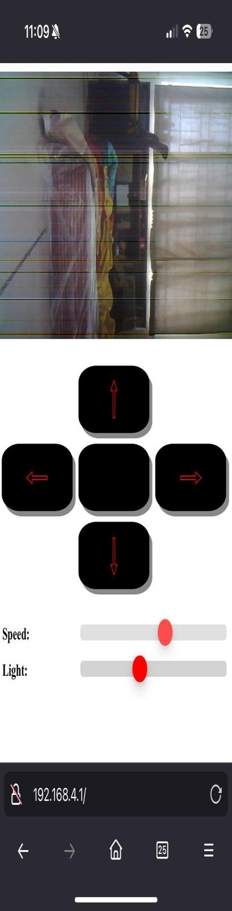
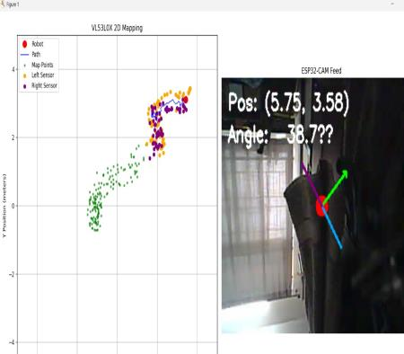
sensors,
and
Arduino
UNO,
the
system
is
capable
of
streaming live video, processing distance data from multiple
sensors, and enabling smooth control of robotic movement.
The use of OpenCV for trajectory tracking further improves
navigation
accuracy,
providing
real-time
feedback
to
operators in hazardous environments.

While the system performs well in controlled settings, it
also highlights several real-world advantages, including its
affordable components, ease of deployment, and versatility
in
remote
environments.
The
ESP32-CAM’s
Wi-Fi
capabilities enable effective remote control and visualization,
eliminating
the
need
for
costly
infrastructure
while
maintaining reliable communication. The VL53L0X sensors
provide
accurate
distance
measurements
for
obstacle
detection, which is critical for safe navigation in unknown
terrains. Furthermore, the system’s integration of both visual
and
distance
data
offers
enhanced
situational
awareness,
significantly improving the robot's performance in complex
rescue operations.

However, the system also has its limitations, including
latency in sensor data processing and power consumption,
which could be addressed with future optimizations. Despite
these challenges, this solution represents a promising and
affordable approach to robotic rescue operations, offering a
practical
and
scalable
platform
for
disaster
management.
With further refinement, it has the potential to be adapted for
larger-scale applications, making it an invaluable tool in
modern rescue and exploration scenarios.
K

EYPOINT SUMMARY

a)
System architecture of the Python–ESP32-CAM
robot interface for real-time video and sensor
streaming. The Python-based system connects to the
ESP32-CAM's Wi-Fi Access Point, establishing a
dedicated wireless link for continuous video and
sensor data transfer. The ESP32-CAM handles the
Wi-Fi network setup, camera initialization, and
sensor interfacing, while the Python client runs
parallel processes to capture the live camera feed
(via OpenCV) and the incoming sensor telemetry
concurrently. This design enables real-time path
tracing and obstacle monitoring on the PC side with
minimal latency, as illustrated above.

b)
Streams the robot’s onboard camera feed to the PC
in real time using OpenCV, providing a continuous
first-person video view of the robot’s environment
for monitoring.

c)
Continuously reads distance measurements from the
robot’s front, left, and right Time-of-Flight (ToF)
sensors to facilitate obstacle detection. This sensor

data is fetched in parallel with the video stream via

a serial link, ensuring that obstacle information is
updated in sync with the visual feed.

V.
C

ONCLUSION

d)
Maintains a live 2D map of the environment using
In conclusion the Real-time Path Tracing System for
matplotlib to trace the robot’s path and plot detected
Reconnaissance and Rescue Operations showcases a low-
obstacles. The robot’s position on this map is
cost, efficient solution for enhancing remote control, and
incrementally updated using the ToF sensor inputs,
real-time mapping in reconnaissance and rescue missions.
so the visualized path and obstacle markers
Through
the
integration
of
the
ESP32-CAM,
VL53L0X
accurately reflect the robot’s movement and its
R

EFERENCES
surrounding obstacles in real time.

e)
Handles disconnection scenarios with robust retry
[1] Y. Pan, X. Zhong, L. Wiesmann, T. Posewsky, J. Behley, and C.
logic. If the Wi-Fi or data connection to the ESP32-
Stachniss, "PIN-SLAM: LiDAR SLAM using a point-based implicit
neural representation for achieving global map consistency," IEEE
CAM drops, the system automatically detects the
Transactions on Robotics, vol. 40, no. 6, pp. 1234-1246, Jun. 2024.
loss and attempts to reconnect. Once the link is re-

established, the video and sensor streams
[2] J. Liu, W. Zhang, and C. Wu, "Robust LiDAR-visual SLAM in
immediately resume, minimizing downtime.
dynamic environments," IEEE Robotics and Automation Letters, vol.

9, no. 4, pp. 5627-5634, Aug. 2023.

[3] S. Cao, Z. Wang, and J. Yang, "LiDAR-visual SLAM for indoor
navigation with feature point matching," IEEE Access, vol. 11, pp.
A

CKNOWLEDGMENT
78945-78955, 2023.

[4] S. H. V. Torres, R. Chen, and M. Kumar, "Enhancing real-time
We would like to express our gratitude to the faculty and
path tracing in autonomous rescue missions using ESP32-CAM and
staff of Vellore institute of technology for their invaluable
Time-of-Flight
sensors,"
International
Journal
of
Robotics
and
support and resources during this research. Special thanks go
Automation, vol. 30, no. 2, pp. 230-240, Apr. 2024.
to Ms. Srimathi R for their guidance and insights, which

greatly contributed to the success of this study. Lastly, we
[5] M. D. C. et al., "Real-time SLAM with RGB-D cameras for rescue
robotics," Robotics and Autonomous Systems, vol. 143, pp. 107660,
extend our appreciation to the participants who provided
Dec. 2024.
valuable feedback during system testing

